# Capstone Project - The Battle of Neighborhoods

Introduction

New York City is the most populous city in the United States, with an estimated 2018 population of over 8 million. The city is also one of the most diversified cities in the US. The city's population in 2010 was 44% white, 25.5% black, 12.7% Asian and 0.7% Native American. Among these different races, Asians is the fastest-growing one between 2000 and 2010. As the term "melting pot" described, approximately 37% of the city's population is foreign born. In New York, none of the single country or region of origin dominates.

The diverse culture leads to diverse food cuisines. In New York, you can find all kinds of authentic foreign restaurants, like French, Italian, Japanese, American, Chinese, etc.

In this project, we will list and visualize all parts of NYC which has great Chinese restaurants. The project can help visitors or newcomers to NYC to find their desired good Chinese restaurants. They can also decide which area of NYC they'd like to stay at for good Chinese food.

Data

The following data are needed for this project:

* New York City data that contains list Boroughs, Neighborhoods along with their latitude and longitude.
  + Data source : <https://cocl.us/new_york_dataset>
  + Description : This data set provides the location of various neighborhoods of new york city.
* Chinese resturants in each neighborhood of new york city.
  + Data source : Fousquare API
  + Description : We will get all venues in each neighborhood and then filter them to get only Chinese restaurants.
* GeoSpace data
  + Data source : <https://data.cityofnewyork.us/City-Government/Borough-Boundaries/tqmj-j8zm>
  + Description : New york Borough boundaries for better map visulization.

Methodology

* Collect the new york city data from <https://cocl.us/new_york_dataset>
* Using FourSquare API to gather all venues for each neighborhood.
* Filter out all venues that are Chinese Resturants.
* Find rating , tips and like count for each Chinese Resturants using FourSquare API.
* Using rating for each resturant , we will sort that data.
* Visualize the Ranking of neighborhoods using Python folium library.

We will import the required libraries for python.

* pandas and numpy for handling data.
* request module for using FourSquare API.
* geopy to get co-ordinates of City of New York.
* folium to visualize the results on a map

First of all, we visualize number of neighborhood for each Borough in New York City:

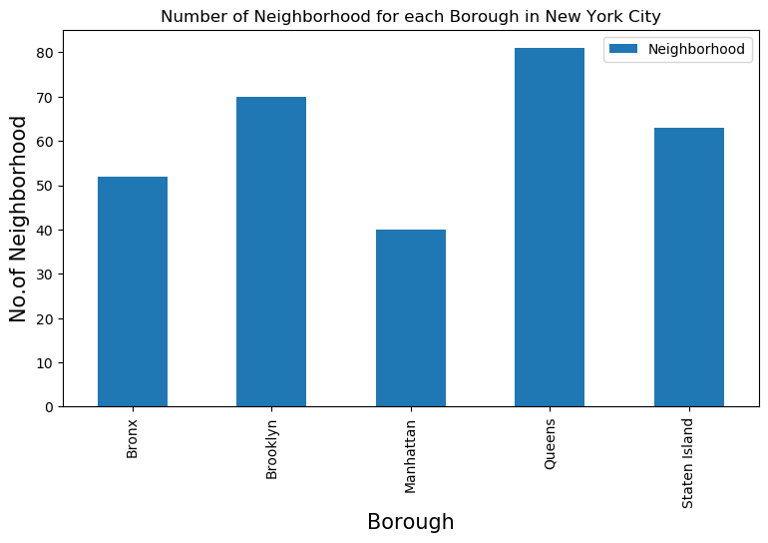

We see that Queens has highest number of neighborhoods

Then, use the data get from FourSquare API, we visualize the number of Chinese restaurants for each Borough in New York City:

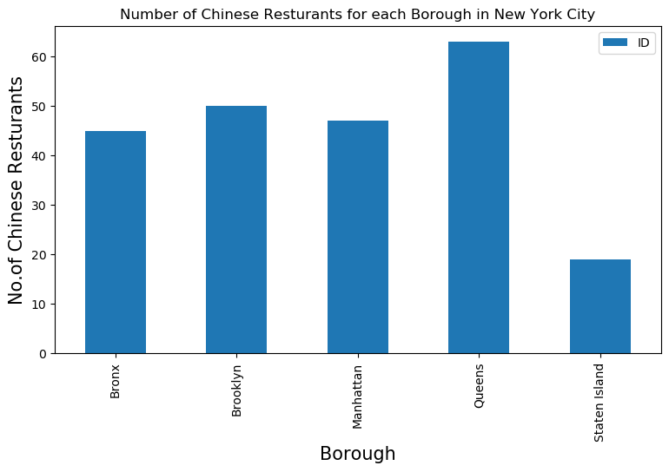

We see that Queens has the largest number of Chinese resturants.

We can also show the number of Chinese restaurants for each neighborhood in New York City:

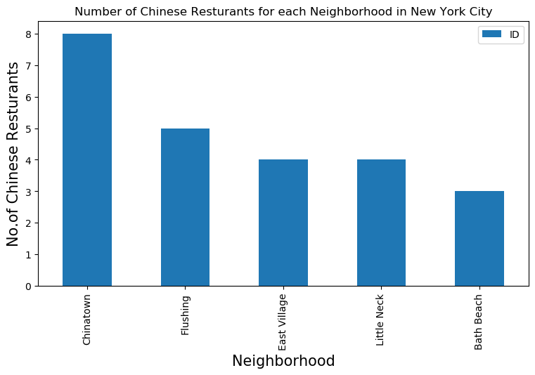

So Chinatown in Manhattan has the highest number of Chinese Resturants with a total count of 8.

Now we will get the ranking of each resturant for further analysis. We can visualize the average rating of Chinese Resturants for each Borough:

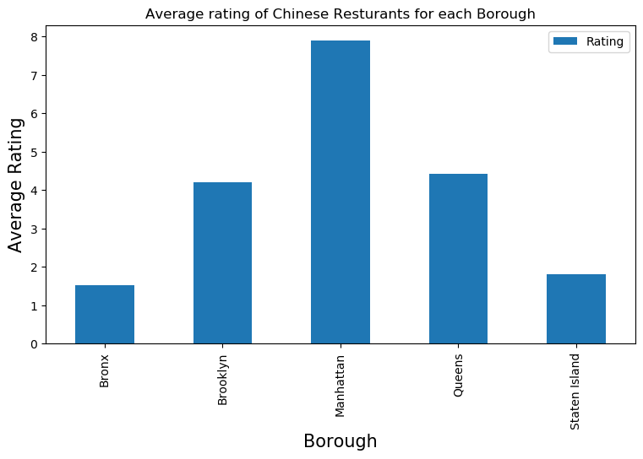

We will consider all the neighborhoods with average rating greater or equal 9.0 to visualize on map

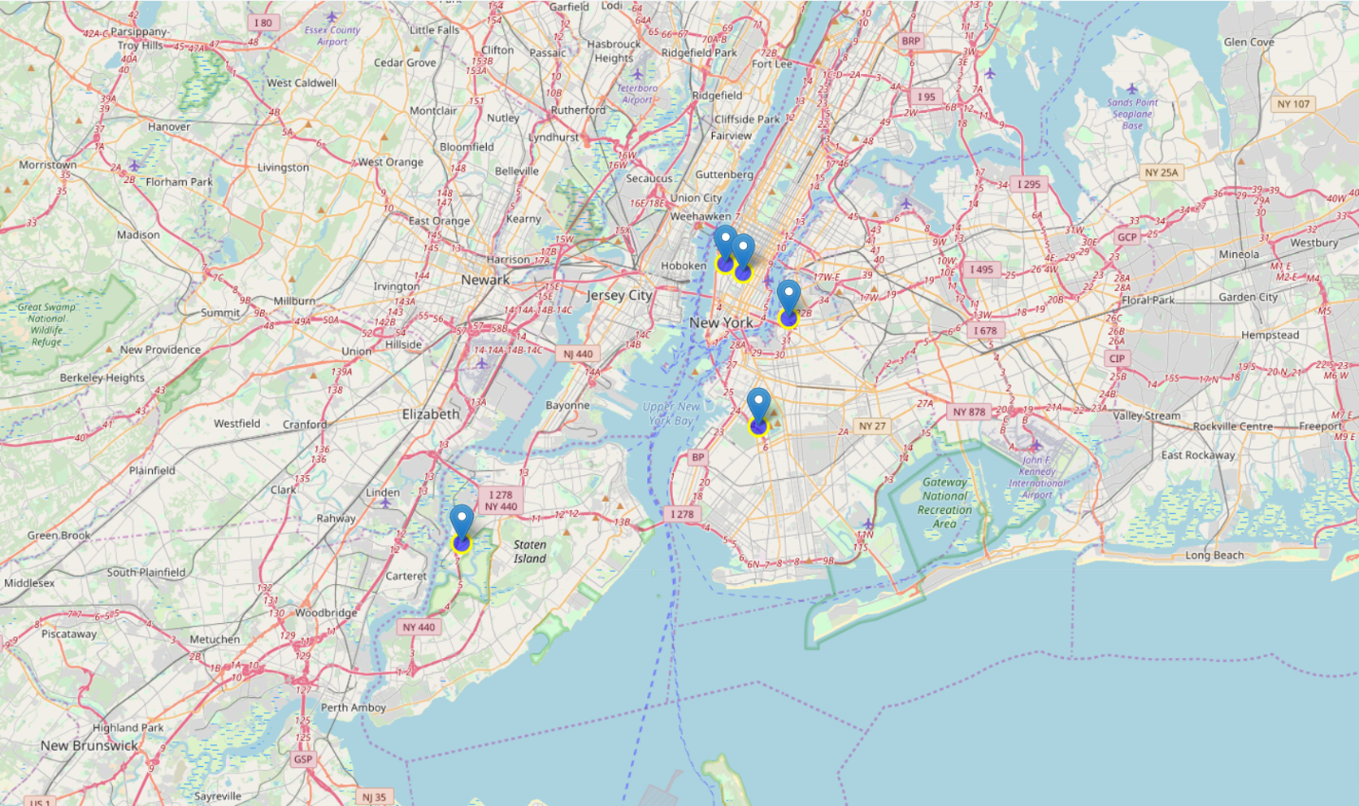

Then let’s show the average Chinese restaurant ratings for all Boroughs in New York City.

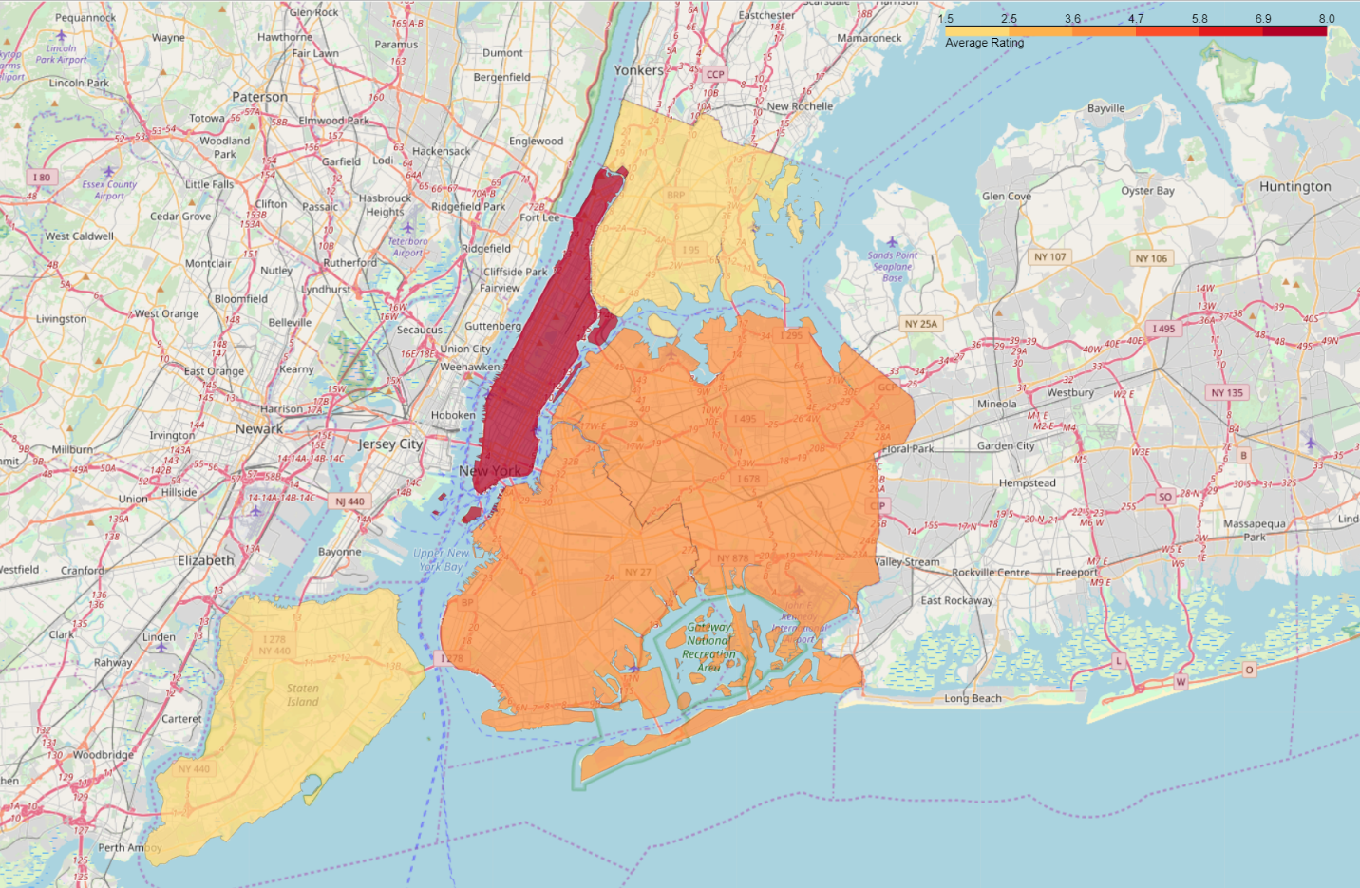

Results

* Chelsea(Manhattan), North Side(Brooklyn), Flatiron(Manhattan) are some of the best neighborhoods for Chinese cuisine.
* Even though Chelsea(Staten Island) has a very high average rating, since the Chinese restaurant in Staten Island is very few, this place may not be considered as a good place for Chinese food.
* Staten Island ranks last in average rating of Chinese Resturants.
* Manhattan, Queens & Brooklyn are all good places for Chinese food. Overall Manhattan has a good balance between restaurant numbers and ratings.

Conclusion

In this project we studied the Chinese restaurants in New York City and try to determine which neighborhood is good for having some good Chinese food. We use new york city data and FourSquare API to gather all venues, filtering out Chinese restaurants and then sort the data base on their ratings. Finally we do the data visualization of the average Chinese restaurant ratings for every neighborhoods in New York.